**Project Title:** Educational Organisation Using ServiceNow

**Team ID : NM2025TMID15233**

**Team Size :** 4

**Team Leader :** SNEHA A

**Team member :** SHERLIN DEEPIKA M

**Team member :** VIGNESH P

**Team member :** VISHAL S

**Objective** : Used to do Admissions, To store students progress in an Educational Organisation

Image 1: This is Admission Page, it is used to create new admissions and move the process to the next.

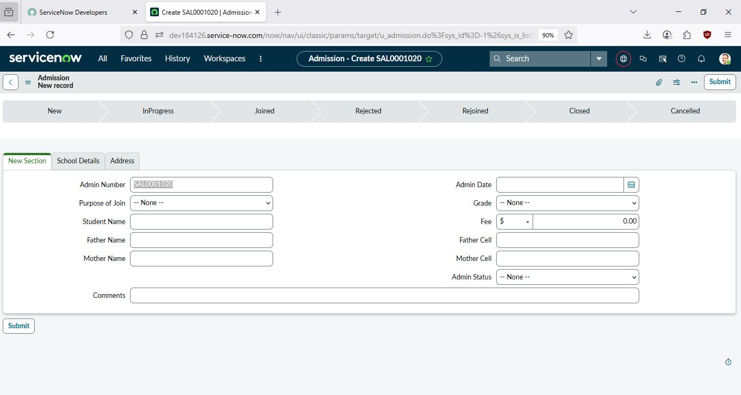

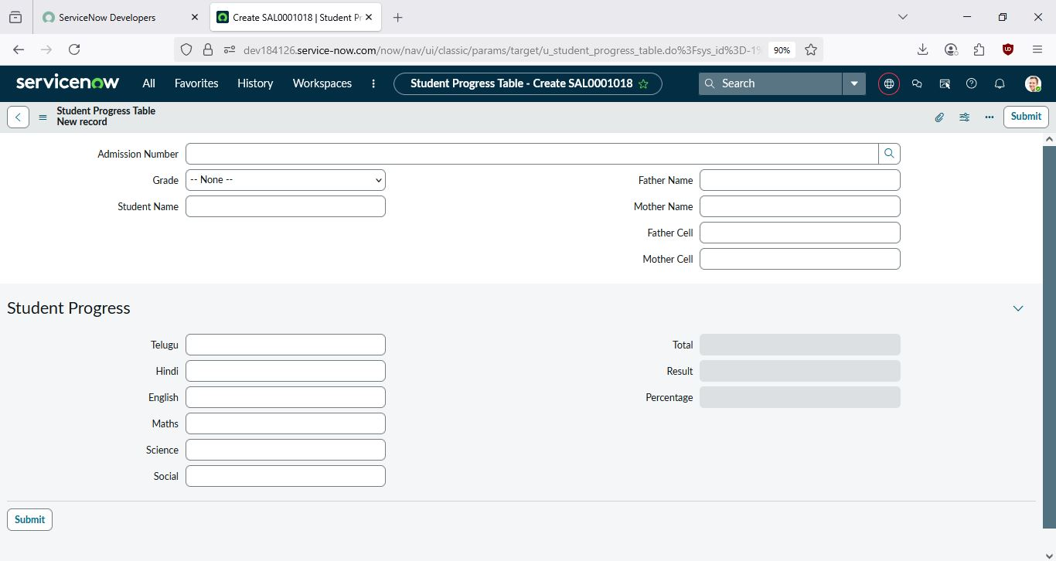Image 2: This is Student Progress Table, It used to enter the marks that the students has scored in each subject, it will show the whether the student is pass or failed, and it also shows the percentage that the student scored